BLOODLINK:AMOBILE-BASEDHYBRIDBLOODBANKFOR REDCROSSMUNTINLUPACHAPTER

A Capstone Project Presented to the Faculty of the
College of Information Technology and Computer Studies
Pamantasan ng Lungsod ng Muntinlupa

In Partial Fulfilment of the Requirements for the Degree
Bachelor of Science in Information Technology

FADERANGA, JANREY CYRIL C.
PANGILINAN, KYRAH A.
SANTARIN, MARY GRACE S.

2024
TABLE OF CONTENT
PRELIMINARIES
Title Page
Acknowledgement
Dedication
Table of Content
List of Figures
List of Tables
CHAPTER
- INTRODUCTION
Project Context
Purpose and Description
Objective of the Study
- General Objectives
- Specific Objectives
Scope and Limitation

- REVIEW OF THE RELATED LITERATURE AND STUDIES
Technical Background
Related Literature
Related Studies
Definition of Terms

- METHODOLOGY
Requirement Analysis
Requirement Documentation
System Architecture
Design of Software, Systems, Product and/or Processes
Development and Testing
Project development
Testing Procedure
Implementation Plan

- RESULT AND DISCUSSIONS
Project Description
Project Structure
Project Capabilities and Limitation
Project Evaluation

- SUMMARY OF FINDINGS, CONCLUSIONS
Summary of Findings
Conclusions
Recommendation

REFERENCE

APPENDICS

Sample Evaluation Instrument (for IT experts)
Sample Evaluation Instrument (Actual Users)
Gantt Chart
Picture Showcasing the Data Gathering, Investigation done
Curriculum Vitae Per Team Member
.
LIST OFFIGURES No. Title

- Sample Screen of Sample page
- Sample Screen of Sample page
- Sample Screen of Sample page
- Functional Decomposition Diagram
- Function Decomposition Diagram of the proposed system
- System Architecture of the proposed Application
- Conceptual Model Of the study
- Rapid Application Development (RAD) Development
- Sign In Page Of Bloodlink Red Cross Muntinlupa for Donors and Recipient
- Sign Up Form
- Dashboard Page
- Home Dashboard
- BloodBank
- Set Up Appointment Page
- Bloodstock Page
- Donation Drive Page
- Pre-Registration
- Donation ID
- Donation Setting
- Donation History
- FaQs Page
- Request Page
- Blood Group Selection Page
- Donor Page

LIST OF TABLES No .Title

- Alpha Testing
- Beta Testing
- System Evaluation Characteristics
- Likert Scale
- Implementation Table
- Testing Results
- Sample Size Of Respondents
- Weighted Mean and Descriptive Rating of the Evaluation of the I.T. Experts using the ISO/IEC 25010:2011 Software Evaluation
- Weighted Mean and Descriptive Rating of the Evaluation of the Actual Users using the ISO/IEC 25010:2011 Software Evaluation

CHAPTER 1
INTRODUCTION
Project Context
The Mobile-Based Hybrid Blood Bank for Red Cross Muntinlupa Chapter is a strategic effort to modernize the blood bank system by integrating mobile technology. It aims to transform interactions between donors and recipients with the Red Cross Muntinlupa Chapter, making blood donation more accessible, efficient, and engaging through a hybrid system that combines a mobile app with traditional blood bank operations. The primary problem addressed by this project is the inefficiency and limited accessibility of traditional blood banking systems. Challenges such as manual appointment scheduling, lack of real-time inventory updates, and difficulty in reaching potential donors highlight the need for a more streamlined and technology-driven approach to blood donation management. The proposed project will develop a user-friendly mobile application interface specifically designed for blood donors and recipients. This application will enable users to easily register, schedule donation appointments, and receive timely notifications regarding blood donation campaigns and urgent supply needs. By integrating this mobile-based system with the existing blood bank infrastructure, seamless data flow and coordination will be achieved, enhancing overall efficiency and accessibility within the blood donation ecosystem. The proposed Mobile-Based Hybrid Blood Bank system will benefit both donors and recipients within the Muntinlupa community. Donors will experience greater convenience in scheduling donations and receiving updates on blood supply needs. Recipients will benefit from improved access to blood and enhanced coordination between donors and the blood bank. This innovation aims to bridge the gap between supply and demand, ultimately saving lives and strengthening community healthcare infrastructure.
Purpose and Description
The purpose of this capstone project is to design, develop, and implement a Mobile Based Hybrid Blood Bank system for the Red Cross Muntinlupa Chapter. This system will revolutionize blood banking operations by integrating mobile applications with the existing centralized blood bank infrastructure. The envisioned system will enable users, both donors and recipients, to interact seamlessly with the blood bank, facilitating processes such as registration, appointment scheduling, real-time blood type availability checks, and participation in blood donation campaigns. The power of mobile technology in this generation was continuous and widespread and aimed to address key challenges faced by traditional blood bank systems, including limited accessibility, inefficient coordination, and lack of real-time information dissemination. The Mobile-Based Hybrid Blood Bank will empower users to actively participate in blood donation initiatives and contribute to saving lives within their community.
Beneficiaries:
Red Cross Muntinlupa Chapter- Improved blood bank operations and campaign management.
Blood Donors - Easy registration, appointment scheduling, and real-time updates on blood donation.
Blood Recipients - Faster access to available blood types and improved emergency response.
Healthcare Providers - Better coordination with the blood bank for patient care.
Local Community - Increased awareness and participation in blood donation efforts.
Benefits:
Enhanced Accessibility-Users can access blood bank services anytime, anywhere.
Real-Time Information- Instant updates on blood availability and donation campaigns.
Improved Efficiency- Faster and more accurate matching of donors and recipients.
Better Resource Management-Optimized blood inventory and reduced waste.
Increased Community Engagement-Encourages more blood donations through a user friendly platform.

Emergency Support-Quicker response in emergencies, potentially saving more lives.
Objective of the Study
General Objective
The main objective of this study is to develop and implement a Mobile-Based Hybrid Blood Bank system for the Red Cross Muntinlupa Chapter, integrating mobile technology with traditional blood banking operations to enhance accessibility, efficiency, and engagement in blood donation processes.

Specific Objectives
- To design the system with the following features:
- Provides user login/register functionality to create and manage accounts.
- Provides a form of Pre-screening Health Assessments for potential donors.
- Capable of managing scheduling for blood donation appointments.
- Capable to provides user notifications about donation opportunities and reminders via portal
- Provides a dashboard for real-time inventory updates that track the available blood units and its details.
- Provides location services details to support users to find nearby donation centers and events using display address only.
- Display educational resources on blood donation process and health tips.
- Report generation on donation trends, inventory levels, and user engagement.
- To develop the system using React Native and Expo for mobile development, Native Wind CSS for styling, Node.js for backend logic, and PostgreSQL as the database, managed via Supabase.
- To test and improve the functionality of the system using Alpha and Beta Testing methods.
- To evaluate the performance of the system using ISO/ IEC 25010: 2011 Software Characteristics.
- To implement the system to the Red Cross Muntinlupa Chapter.

Scope and Limitation
The project aims to design and develop a mobile-based hybrid blood bank system tailored specifically for the Red Cross Muntinlupa Chapter. It will provide a user-friendly application that facilitates direct interaction between blood donors and recipients, offering seamless integration with the existing centralized blood bank system for real-time data exchange, and location-based services to help users find blood donation centers and events.
However, there are several limitations to this project. It is restricted to the development of the mobile-based system and does not address broader organizational or staff-related changes within the Red Cross Muntinlupa Chapter. Additionally, the system is designed to support only Android devices running version 10 and above, excluding iOS users. Potential issues related to mobile device compatibility, internet connectivity, and the integration of external systems beyond the existing blood bank infrastructure may also pose challenges that are not within the scope of this project.

CHAPTER 2

REVIEW OF THE RELATED LITERATURE AND STUDIES

This chapter presents the review of related literature and related studies underlying the framework of the study. It includes the conceptual model of the study and the operational definition of terms.

Technical Background
The application will be developed using JavaScript for both front and back end, leveraging frameworks such as React Native, React and Expo SDK 52 and up. The Supabase platform will be used as the database and mobile host, while Vercel will serve as the web host. These technologies enable cross-platform compatibility, allowing the same codebase to be used for Android platforms. This approach reduces development time and costs compared to building native apps for each operating system.
The system will include a secure user authentication mechanism, such as user login, to safeguard the privacy and security of donor and recipient data. Users will create profiles that include their full name, date of birth, blood type, and contact information. The application will also feature a donor eligibility checker to ensure donors meet the necessary criteria before donating, as well as a blood compatibility checker to verify that donors and recipients only donate or request blood types they are compatible with.
The Blood Inventory Management system will maintain a real-time inventory of available blood types and quantities. Staff members will be able to update blood inventory levels, and provide blood stock levels. The application will also provide notifications via app to alert users about urgent blood needs, upcoming donation events, or changes to their appointments.
By incorporating these technologies, the mobile-based hybrid blood bank application aims to streamline the blood donation process, improve donor engagement, enhance inventory management, and facilitate effective communication between all stakeholders involved in the blood donation ecosystem.

Related Literatures
In 2023, Li et al .(2023) Proposed a system Donating blood without payment is a selfless act of civic duty, and the addition of gamification features to blood donation applications can improve the experience of donors, particularly young people. This study examines the features and gamification components of the mobile blood donation apps currently available. Three duplicates were found out of 801 apps during a search that was conducted in Google Play, Apple Apps store, Blackberry App World, and Windows Mobile App shop to choose 10 gamified BD apps. The findings indicate that traditional and social login are the most common forms of authentication, and that most blood donation applications do not support various languages.[1]
According to the authors, technological advancements and the widespread use of mobile devices have significantly accelerated the development of mobile applications in the health sector. Blood donation centers often experience blood shortages due to insufficient donations. Consequently, social networks frequently display urgent blood donation requests for specific blood types. Mobile applications designed for blood donation are essential in the health sector as they facilitate immediate communication between donors and blood donation centers. This prompt coordination minimizes the time required for the donation process. [2]
The blood is a lifesaver if there ever emerges any events of the emergency needs. The errand of the blood bank is to get the blood from the different types of people caning to donate the blood, to manage blood bundles’ database and to provide the needed blood in between of the need to the mending donation if there emerges any events of emergencies. The issue here isn’t the lacking number of the people caning to donate the blood, but finding any enthusiastic supporter/donor at the advantageous time. We have to make an arrangement of people who may help each other in between of an emergency. The android application in this project prompts the updates of the information for the supporters/donors where the chief gets the entire information about the blood bank system.
Give away/donor can then be incited into entering a man’s purposes of information, like name, email, phone number, and the blood group. At the usual time of any blood need, one can quickly check the red blood blank android application database or recuperating database planning related or explicit the blood gathering and the interface with them through android application. The blood bank android application gives away all over information of the blood bank android application focused on your region. A noteworthy number of people caning to donate the blood can be pulled into using this android application. Since about every one now carries mobile phones with them, to ensure minute region surveillance and correspondent changes. Only an enrolled individual self, with the capacity to give away the blood, can have the ability to get to the society. In this android application we are using the GPS advancements which can be used to be pursued the course to the blood bank. The customer can get the course to be accomplished using the pin for each region and they will not be asking physically, thus time can be saved. With uprising of correspondence nowadays, one needs headways upgrades to all territories, especially for prosperity space.
This report gives an android application a system which is planned to give away most information needed for the blood social circle or affair which is reliably asked for an advancing reason. The system depicts the convenience and the ease to contact with different suppliers and dejects for different blood social events. The android application acquaints on the insightful contraptions with the assurance of the arrival of a greatest possible no. Of the red blood benefactors within the country. This tackles PDAs with the android system laid by the blood bank.[3]
Medical monitoring requires instant visibility across data sources and access to dynamic analyses. However medical monitoring among patients, perform in-stream medical advice, remains a challenging problem. Blood banks suffer frequent shortage of blood due to lack of blood donations, hence blood donation requests are frequently seen on social media for patients who urgently require blood transfusion with specific blood group. Recently, worldwide efforts have been undertaken to utilize social media and smart phone applications to make the blood donation process more convenient and provide a concrete information system that allows donors and blood donation centers to communicate efficiently and coordinate with each other to minimize time and effort required for blood donation process. This paper aims at developing a Cloud medical monitoring and Web-Based Blood Donation System which will allow blood donors and patients to offer/request blood donation from blood banks. Additionally, a new method is proposed for continuous observation and communication among doctors and patients. Using IOT cloud platform, simple medical devices equipped with medical sensors can monitor health status of patients and update the electronic medical records of patients’ information. Medical experts can remotely monitor patient’s dynamic status and give prompt medical advice.
The developed Web-Based application utilizes a cloud-based hosting platform to enhance system performance and ensure high availability. A mobile application has been developed where users will be able to use as an application installed on their smart phones to help them complete blood donation process with minimum effort and time. This application helps people receive remotely medical advices and helps establish a blood donation community through social networks. This paper also presents various tools that were used to measure system performance. [4]
In the field of healthcare management, blood donation is of particular interest due to its crucial and vital importance in saving lives. In Iraq, the blood donation procedure often takes a long time for donors because it is done through an unautomated and paper based process, only done at hospitals/medical centers for those who are willing Blood Donation. Patients who need to donate blood may have to wait to receive this service, which can lead to serious or unwanted consequences. At the same time, the blood donation process negatively affects those who want or desire to donate blood and often causes many of them to ignore the issue, unless there is an emergency situation related to blood donation. This article proposes a Mobile Blood Donor Registration System (MBRS_BD) using Firebase Cloud Messaging (FCM) to automatically manage the blood donor registration process using smartphones to simulate and facilitate convenient and minimize the time needed for this. Donors can register at any available Iraqi hospital/medical center using MBRS-BD and arrive at the exact time to complete their donation process.[5]
Blood is an essential element of human life and nothing can replace it. The World Health Organization (WHO) recommends that countries focus on youth to achieve 100% voluntary, unpaid blood donation by 2020. Blood donation can be lifelong save for people who have lost large amounts of blood due to serious situations, obstetric and gynecological hemorrhage or surgical interventions and stem cell transplants, as well as for people with symptomatic anemia due to medical or hematological problems. Blood banks have a mission to provide adequate services and safe blood to the community. Urgent crises such as accidents require rare blood types or anemia.
The hospital needed to reach a large number of donors and there was no way to do that. This is the dilemma we want to solve with our app. Any blood pooling center that reorganizes Gail registers itself in the system so that it can receive blood supplies in case of shortages. Tools used in the project development is PBP, MYSQL and HTML. The system developed will fill the main gaps that exist in terms of connectivity and interaction between blood banks and hospitals[6].
Related Studies
Blood donation is a vital process that saves countless lives every day. In the Philippines, the Philippine Red Cross plays a crucial role in supplying blood products to those in need. However, the current paper-based procedures used by the Red Cross can be time-consuming and inefficient, leading to delays and sluggish service. With the advent of technology, there is an opportunity to develop innovative solutions that can streamline the blood donation process, making it more efficient and effective. This study aims to explore the development of a mobile-based hybrid blood bank application for the Red Cross Muntinlupa Chapter, building upon the successes and lessons learned from previous automation efforts. The research on the development of a Blood Management System with Donor Finder for the Red Cross Laguna Chapter in 2019 showcased the potential benefits of automating blood donation processes and enhancing service delivery within the organization.
According to [7], apart from the numerous advantages they offer in our day today existence, computers and mobile phones have grown increasingly ubiquitous in our society. The Corona pandemic and the problems it raised made internet communication— through websites and applications—essential. Many lives could be lost as a result of the difficulty in finding a reliable blood bag. Donating blood is essential for thalassemia patients, cancer patients, accident victims, and surgery patients.
Finding and visiting a blood bank is necessary in order to donate blood. Selecting the best donor in a pinch could be difficult. Recipients frequently struggle to locate the right blood donor since uncommon blood types aren't always available at all blood banks. To deal with the matter of the removal of rare blood types, poor management of blood banks, a lack of knowledge and confidence, and the difficulty of identifying a particular blood type are all contributing factors to the shortage of blood bags. The goal of this project is to create and implement a mobile application. Using a blood donation app that is linked to the central database, which aggregates and organizes data from all blood banks and donation drives, is recommended. The suggested application oversees and controls every procedure required for blood donation.[8].
According to [9], files are the main emphasis of the blood bank's current storage system. This guarantees that information regarding blood, donors, and Recipients are kept in archives and documents. Processing data and information becomes challenging and time-consuming. of this. Physical records of all blood donor and transfusion tests are also kept. Information is therefore powerless to Human error and mistakes lead to dangers to human life. Another fundamental issue with this structure is penurious efficiency. It takes a lot of work to get blood due to the laborious process, whether it is donor or recipient information. The current blood bank's storage system primarily focuses on files, making data processing challenging and time-consuming. This system also keeps physical records of donors and transfusion tests, making it vulnerable to human error and potential dangers to life. The system also lacks efficiency, making it difficult to retrieve blood during critical moments. Additionally, information backup and security are crucial, as papers and records can be easily lost or stolen. The project aims to provide a platform with all registered blood donations data, enabling quick blood delivery. The project has been thoroughly researched on blood management systems and procedures, aiming to optimize its potential. A blood donation management system should have an information mechanism for recipients, donors, and other interested parties, and ensure transparency about blood inventory status. Identifying and addressing the shortcomings of the current system is crucial for the project's success
According to [10] each year, millions of lives are saved by blood donation. It can assist cancer patients receiving treatment, prior to mature infants, high-risk pregnant moms, Patients with hematopoiesis requiring transfusions treatment, hurt, and possibly deadly defectsfacilitates and supports intricate medical and medical operations.Giving blood while adhering to the equity principle symbolizes a significant social movement of unity interactions and life support via volunbiased, selfless, and devoid of bias behavior. obtaining blood products and therapies fits with one of the tactics intended to achieve equity in the public health system, serving as an vital element of efficient health system.
According to study of [11], blood donation is crucial for managing and saving lives. An automated system for managing and scheduling blood donation events could be developed to improve the efficiency of this procedure. They created an integrated architecture for a blood management system in this study that includes all connected but separate web-based subsystems. As a crucial component of the integrated system, we suggest a data warehouse (DW) to keep historical blood donor data in a centralized database for processing analytically. Based on the analytical findings from the DW for a specific region for a specific time and citizen demography, the proposed system would allow the authorities to make well-informed decisions for blood donation camping. Lastly, we present a brand-new humanity-measuring system score system.
In 2018 based on the study of [12], Blood services are vital because they have the potential to save lives. Lack of a platform to arrange appointments for blood donations and blood requests causes issues like ignorance about the procedure for donating blood and requesting blood. A framework for creating an Android mobile application that will streamline blood services between blood banks, donors, and blood requesters is presented in this paper. The planned system will enable blood banks to oversee blood donations and requests, monitor up-to-date data on the state of blood services, and organize blood campaigns to encourage more people to give. Blood donors will be able to easily organize blood donation appointments or take part in blood drives thanks to the proposed smartphone application.
In 2017 based on the study of [13], when a patient requires blood, the clinic where they are admitted will use the app's "Send Request" feature to ask registered volunteers in the same or neighboring state or city to donate. In the event that a patient is admitted to a clinic, for instance, donors who reside in the Markham and Brampton areas might also receive notification. Depending on the patient's needs, the requester can notify donors as an emergency or as usual, Sometimes, procedures are planned ahead of time, and blood donations are then recorded as usual if necessary. Following the fulfillment of a request, i.e., the successful donation, the clinic might provide the prior beneficiaries with an update. "BloodRequests Feed" displays requests from other users.
The application's features are explained, and their usage requirements are examined. Using the clinic management feature of this program, blood donors nearby can be notified if a patient at the clinic requires blood. Only if the registered donor's blood type and location match the requested blood type will they be notified about blood requests. Donors who match can then visit the clinic making the request to donate blood
In 2016 study of [14] evaluated the COVID-19 pandemic's effects on blood donors and transfusions in Nigeria in a paper published in 2016. According to the study, there was a notable decrease in blood donations and transfusions as a result of the epidemic, with a 17.1% drop in donations and a 21.7% loss in transfusions. The departments that saw the biggest drops in platelet transfusions and fresh frozen plasma were the surgery and accident and emergency departments. The necessity of bolstering blood services during public health emergencies is highlighted by this research.
According to [15], the blood donation saves lives in a variety of circumstances. They can have more energy after receiving a blood transfusion to spend with friends and family. Blood can only be given as a gift from individuals; it cannot be produced. Only six pints of blood could be donated by one individual. Thirty-three lives can be saved by one pint of blood. In comparison to other nations, the number of blood donors is extremely low. Here, we suggest a fresh and effective method for overcoming this issue. The app will ask you to enter a person's details, like name, phone number, age, weight, date of birth, blood type, address, and so on, when you simply press the donation button. When blood is urgently needed, we can find a nearby blood donor by by GPS. The software will automatically identify a donor in the area and notify them as soon as the user enters the blood type they require. If the first donor is not available, the system will look through the next person in line automatically. An One Time Password (OTP) will be sent to the donor for verification if they accept the request. a list of donors in your city or area provided by the blood donation app. The donor's information will be automatically deleted after the blood donation for the following three months.
According to [16], through the use of mobile devices and communication technology, mHealth opens up new possibilities for the provision of healthcare services. Blood donation in the medical field is a difficult procedure that takes time to locate a donor whose blood type matches the patient's. In order to provide mHealth solutions that enable the requester and donor to communicate at any time and from any location, we built an android-based blood donation application. This application's goal is to give information about the required blood and the quantity of available donors in the surrounding areas. With the help of our application, the requester can spread the word around the maintained volunteer blood donor network and simultaneously find out who is willing to donate the desired blood. They developed requester-donor profiles in order to assess our application, and we found that it will facilitate better information access in a timely manner and enable quick action in emergency situations.

RELATED SYSTEMS
In the context of a blood bank, various related systems interact to enhance functionality and efficiency. These can include donor management systems, laboratory information systems, inventory management, and transfusion services. Understanding these interconnected systems is crucial for optimizing performance and ensuring seamless operations. Below, we explore some key related systems that often play a pivotal role in the overall operation of a blood bank.
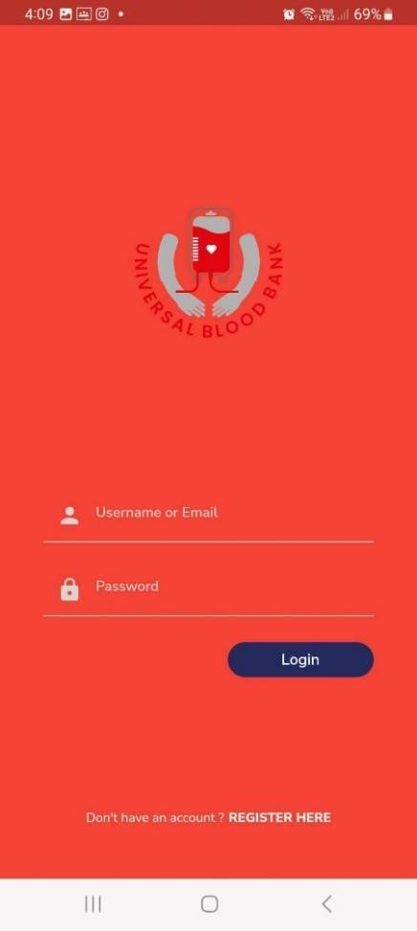
Figure 1. Sample Screen of System Page
Figure 1 shows the login page for a blood bank application it allows users to securely access their accounts by entering a username/email and password. It includes features like "Forgot Password" and "Sign Up" links. The server verifies the credentials, creating a session or token for successful logins, while providing error messages for failed attempts. Security measures include rate limiting, captchas, and optional two factor authentication. Upon logging in, users access personalized features based on their role (donor, staff, or administrator), and the system logs activities for security monitoring.
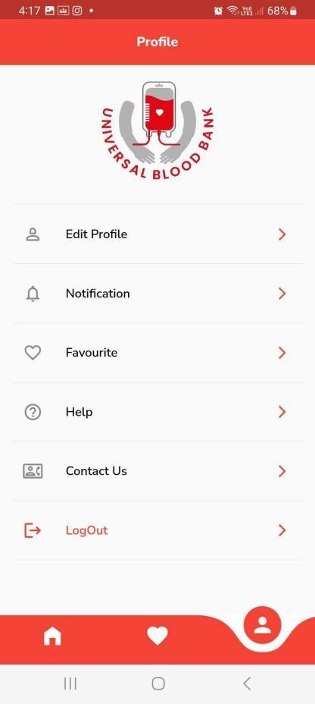
Figure 2. Sample Screen of System Page
Figure 2 shows blood bank dashboard page this is a user-friendly interface that displays real-time information about blood inventory, donor activities, and blood requests. It features an overview of current stock levels for each blood type, alerts for low stock and expiring units, recent donor activities, and upcoming donation events. The dashboard also tracks pending and fulfilled blood requests, shows results from quality control tests, and provides analytics through visual charts and reports. The dashboard is built using web technologies and a secure backend, ensuring efficient and safe management of blood bank operations.
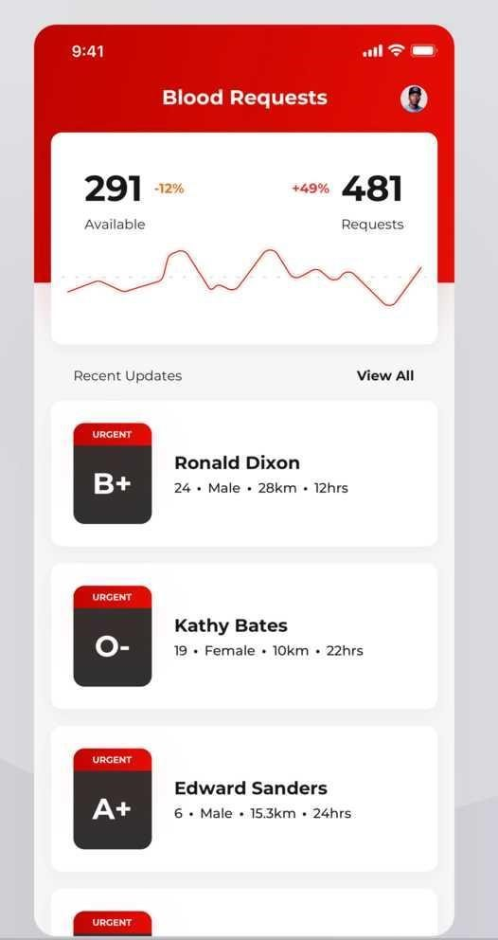
Figure 3. Sample Screen of System Page
Figure 3 shows the blood bank blood stock application helps manage and track blood inventory efficiently. It includes features for registering donors, scheduling donations, and recording blood collection and testing details. The application monitors blood stock levels, alerts staff about low stock or expiring units, and processes blood requests from hospitals. It generates reports on inventory, donation trends, and blood usage, aiding in resource planning. Built with secure web technologies, it ensures smooth and safe blood bank operations.
Definition of Terms
For clarity of presentation, the following terms are defined as used in the study. Operational Terms
Blood Donation Programs: Organized events held in various locations such as schools, malls, city halls, and companies to encourage voluntary blood donations. Blood Inventory Management: The process of maintaining real time records of available blood stock, updating inventory levels, and setting alerts for low stock levels.
Blood Management System: A system designed to automate processes related to blood donation, inventory management, donor engagement, and monitoring of blood banks within the Red Cross organization.
Donor Finder: A feature within the system that helps identify and engage blood donors by tracking their donation history and providing recognition for their contributions.
System Evaluation: The assessment of the developed system based on criteria such as functionality, usability, efficiency, maintainability, and portability to ensure it meets the desired objectives.
Technical Terms
ISO 9126: A standard used for evaluating software quality characteristics, including functionality, usability, efficiency, maintainability, and portability.
MySQL: A widely used open-source relational database management system (RDBMS) that stores and manages data for web-based applications.
PHP Programming Language: A popular scripting language used for web development, often employed in creating dynamic web pages and web applications.
Primary Data: Information collected directly from surveys and interviews to determine system requirements and features needed for system development.
Web-Based Environment: An online platform that allows efficient management and retrieval of data, providing access to blood stock inquiries and management features.

CHAPTER 3
METHODOLOGY
In this chapter, the methodologies used throughout the study are described together with the diagram presentation. Here are the following sections that will be discussed in this chapter: Requirements Analysis, Requirement Documentation, Design of Software, System Product and/or Process, Development and Testing and Implementation Plan.
Requirement Analysis
The Red Cross Muntinlupa Chapter faces significant challenges in managing blood donations due to manual appointment scheduling and communication gaps between donors and recipients.
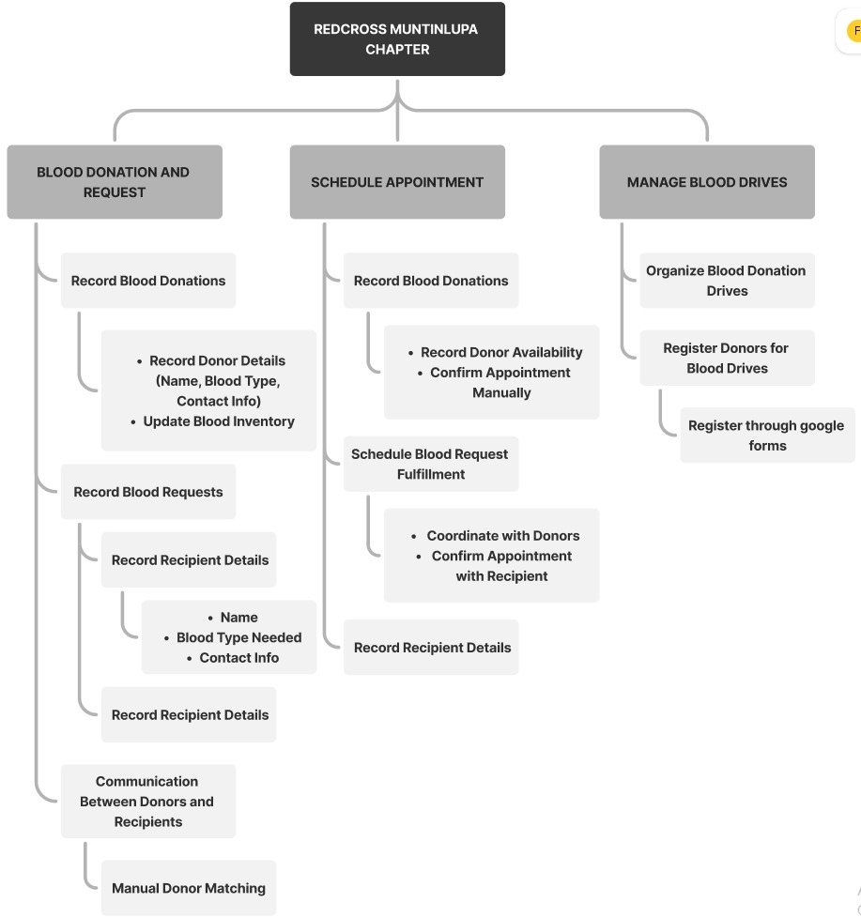
Figure 4. Functional Decomposition Diagram of Redcross Muntinlupa Blood Request Existing Process and Communication Between Donors and Recipients
The Red Cross Muntinlupa Center's appointment and blood request processes are inefficient and prone to errors due to their reliance on phone calls, in-person visits, and record-keeping. Donors contact the center to schedule appointments, and staff check available slots and record information, leading to delays and higher no-show rates due to the lack of automated reminders. Similarly recipients request blood by phone or in-person, with staff verifying inventory and coordinating pickups or deliveries. If the required blood type is unavailable, recipients are placed on a waiting list, and staff reach out to potential donors. This outdated communication method causes delays and hinders quick donor mobilization. An automated system is needed to enhance efficiency, reduce errors, and improve donor and recipient engagement.

Requirement Documentation
The Functional Decomposition Diagram (FDD) for the proposed system at the Red Cross Muntinlupa Center outlines key functions to streamline and improve blood donation management. The system includes automated appointment scheduling through a user-friendly mobile app, efficient blood collection procedures with integrated health screenings, and real-time blood inventory management. Enhanced communication features ensure timely notifications and coordination between donors and recipients. This technology driven approach aims to increase efficiency, reduce errors, and improve the overall blood donation experience.
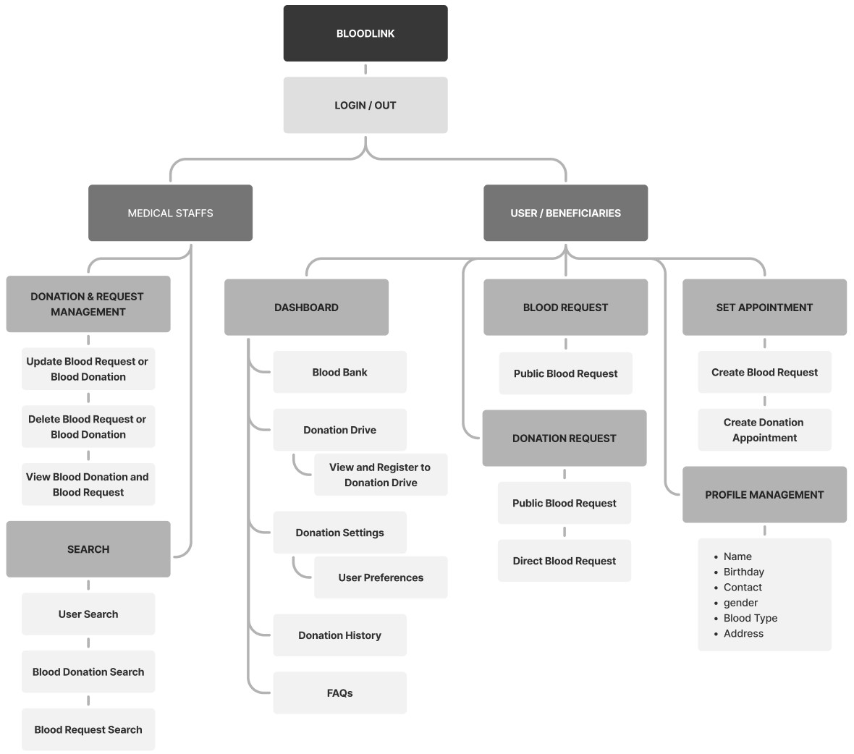
Figure 5. Functional Decomposition Diagram of the Proposed System
Figure 5 shows the functional structure of the BloodLink system, highlighting key features for medical staff and users. It includes donation and request management, user search, dashboard access, appointment scheduling, and profile management. Medical staff manage donations and requests, while users can submit requests, schedule donations, and adjust settings. The diagram illustrates the system's functionality layout.

System Architecture
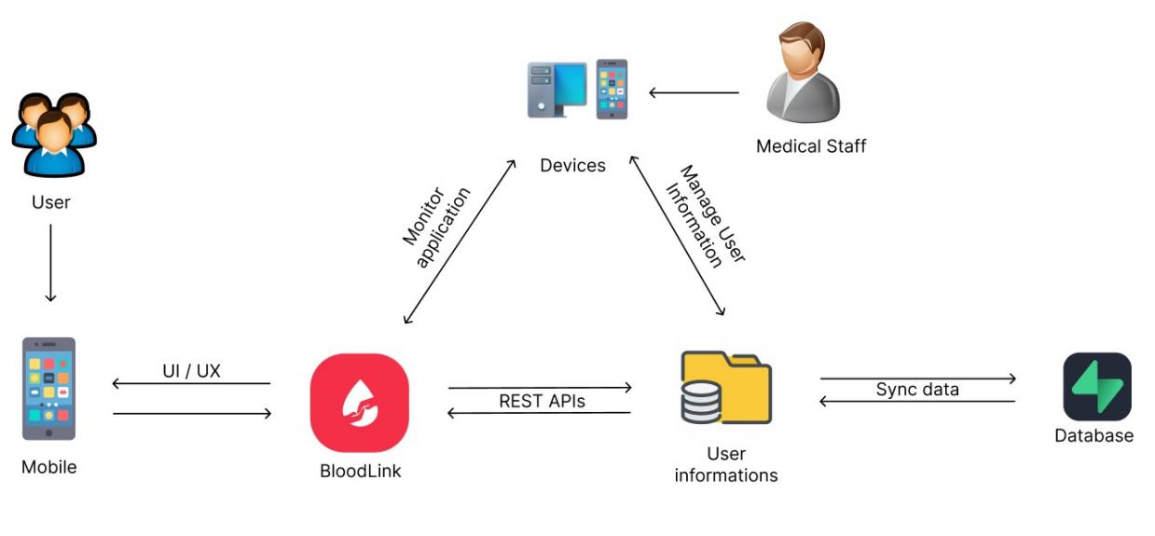
Figure 6. System Architecture of the proposed Application
Figure 6 illustrates the comprehensive system architecture of the proposed application, designed to facilitate seamless interaction between users, staff, and system administrators. The architecture is depicted as a flowchart, emphasizing the integral components and their inter connectivity.
User Interface (UI)/User Experience (UX) component is represented, indicating the point of contact for users through mobile devices. This interface is directly linked to the Muntinlupa BloodLink module, which serves as the core platform for users to submit and retrieve information.
Medical Staff module is shown to have bidirectional communication with both the data submission and information display functions, signifying their role in managing and overseeing these processes.
RESTfulAPIs, showcasing the dynamic capabilities of the system to manage and process data efficiently
Design of Software, Systems, Product and/or Process
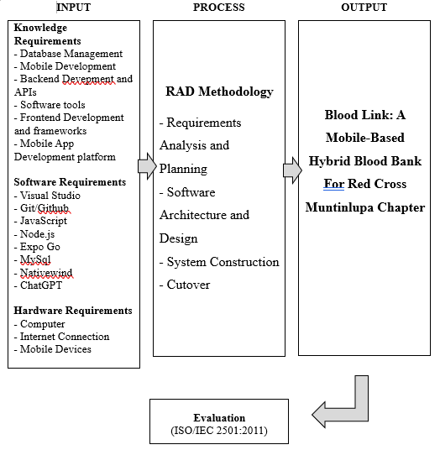
Figure 7. Conceptual Model of the Study
The model outlines a study’s workflow, starting with INPUT requirements such as knowledge and software tools, moving through a PROCESS guided by RAD methodology, and culminating in an OUTPUT that includes a mobile-based blood bank application and its evaluation.
DEVELOPMENT AND TESTING
Project Development
The researchers use the Rapid Application Development (RAD) model is based on prototyping and iterative development with no specific planning involved. The process of writing the software itself involves the planning required for developing the product. Rapid Application development focuses on gathering customer requirements through workshops or focus groups, early testing of prototypes by the customer using interactive concepts, reuse of existing prototypes(components) continuous integration and rapid delivery.
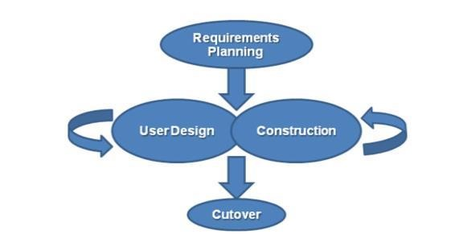
Figure 8. Rapid Application Development (RAD) Methodology
Figure 8 shows a process model that accelerates software development by iterating through four phases: defining project goals in Requirements Planning, refining system design with user feedback in User Design, rapidly constructing a functional model during Construction, and transitioning the product to the users in Cutover. This methodology emphasizes user involvement and rapid prototyping.

Phase 1: Requirements Planning
The researcher first gathers data and plans to develop the system using React Native for the application’s development. In any case, probably in proposing a system the developers should have talked about the mechanics of the plans first before doing the system. The developers should know the problem of the users and even more in the selected beneficiary. The researchers identify that problem and plans its best solution. To develop the application, the researcher gathered/prepared all the requirements to start the application development.
Phase 2: Design phase
The design phase focuses on translating requirements into detailed design specifications. User interface designs, system architecture, and database schema are established during this phase, ensuring a clear roadmap for implementation.
React Native is selected for its cross-platform capabilities, enabling a single codebase for both iOS and Android. Its component-based architecture allows reusable UI elements, ensuring consistency across screens and streamlining development for the blood bank application.
Phase 3: Construction
During the construction phase, the actual development of the mobile-based hybrid blood bank system takes place. Using the React Native framework, the researchers implement features such as donor registration, appointment scheduling, real-time inventory updates, and communication tools. Continuous integration allows for rapid prototyping and iterative development.
Phase 4: Cutover Phase
The cutover phase involves transitioning from the existing blood bank system to the new mobile-based hybrid system. Data migration, user training, and system testing are conducted to ensure a smooth transition. Stakeholder engagement and feedback play a crucial role in validating system functionality and usability.
Testing Procedure
A testing technique is essential for identifying system faults during application testing. While it cannot eliminate all defects, effective and precise testing minimizes errors and ensures the program and its system function as intended.
Table 1
Alpha Testing
Aspect | Alpha Testing
Purpose | Identify and fix bugs, enhance features, and ensure the system meets requirements
Participants | Developers, testers, and selected internal users
Scope | All major features including Database Connection
Focus Areas | Functionality, usability, performance, and security
Duration | Typically shorter, lasting a few weeks
Feedback | Collected from development team
Issue Resolution | Immediate and iterative, as issues are reported and fixed quickly
Output | Improved and more stable version of the system

Alpha testing phase in software development, highlighting its purpose, participants, focus areas, scope, duration, issue resolution, and the expected output of an improved system.

Table 2
Beta Testing
Aspect | Alpha Testing
Purpose | Validate the system's performance, usability, and reliability in real-world scenarios
Participants | A broader group of actual end-users
Scope | Real-world usage of the system by actual users
Focus Areas | User experience, system performance, and overall reliability
Duration | Typically longer, lasting several weeks to months
Feedback | Collected from actual end-users
Issue Resolution | Issues are documented for post-beta fixes and improvements
Output | Final adjustments and fixes leading to the official release

Beta testing phase in software development, which includes validating system performance, usability, and reliability with a broader group of end-users, focusing on user experience and system reliability over several weeks to months, leading to the final product release.
Project Evaluation
The evaluation instrument was based on the characteristics and sub-characteristics provided by ISO/IEC 25010:2011. Respondents of the study were the individual users of the system such as the 10 Information Technology (I.T.) experts and 50 actual users. Purposive sampling was used to select the number of respondents. Purposive sampling is a non-probability sampling technique; it is a form of sampling in which the selection of the sample is based on the judgment of the researchers as to which subjects.
Table 3
System Evaluation Characteristics ISO/IEC 25010:2011 Software Evaluation for both Users and IT Experts
Software Characteristis | Description
Functionality Suitability | Degree to which a product or system provides functions that meet stated and implied needs when used under specified conditions.
Performance  Efficiency | Performance relative to the amount of resources used under stated conditions
Compatibility | Degree to which a product, system or component can exchange information with other products, systems or components and/or perform its required functions, while sharing the same hardware or software environment
Usability | Degree to which a product or system can be used by specified users to achieve specified goals with effectiveness, efficiency and satisfaction in a specified context of use
Reliability | Degree to which a system, product or component performs specified functions under specified conditions for a specified period of time
Security | Degree to which a product or system protects information and data so that persons or other products or systems have the degree of data access appropriate to their types and levels of authorization
Maintainability | Degree of effectiveness and efficiency with which a product or system can be modified by the intended maintainers
Portability | Degree of effectiveness and efficiency with which a system, product or component can be transferred from one hardware, software or other operational or usage environment to another

The statistical tool used in the interpretation of data is weighted arithmetic mean as shown at table 3. Arithmetic mean is used to determine the average responses of the five options in each item, namely, 5(excellent), 4(very good), 3(good), 2(fair) and 1(poor). The arithmetic means for each software characteristic were computed. These were used to derive the overall evaluation mean.
Table 4
Likert Scale
Scale | Range of Mean Value | Interpretation
5 | 4.51 – 5.00 | Excellent
4 | 3.51 – 4.50 | Very Good
3 | 2.51 – 3.50 | Good
2 | 1.51 – 2.50 | Fair
1 | 1.00 – 1.51 | Poor

IMPLEMENTATION PLAN
After finalizing the Blood Link system, it will be presented to the Red Cross Muntinlupa Chapter for evaluation. If approved for implementation, the complete system and its documentation will be submitted to the Red Cross Muntinlupa Center for deployment.
Table 5
Implementation Table
Strategy | Activities | Persons Involved | Duration
Approval from the company | Send letters for the approval of Administrators | Researchers, Administrator | 1 – 2 Days
System  Installation | Installation of the system and checking of the facility that needs an upgrade (software and hardware). | Researchers, Administrator | 2 - 3 Days
Information Distribution | Send Flyers,  Brochures,  Posters, and User  Manual | Researchers, Administrator | 1 Day
3- Day  Training | Hands-on Training and System Demo/ Lectures | Researchers,  Adviser,  Officer and  Administrator | 3 Days

CHAPTER 4
RESULTS AND DISCUSSIONS
This chapter presents the results of the study, detailing the system's functionality, performance, and its effectiveness in addressing the identified problems. The discussion highlights the key findings and their implications for improving blood donation processes.

Project Description
In a capstone project entitled. “ A Mobile-Based Hybrid Blood Bank System” aims to improve the blood donation process for the Red Cross Muntinlupa Chapter by combining mobile technology with traditional blood bank operations. It features a user-friendly mobile application that allows donors and recipients to register, schedule appointments, check real-time blood inventory, locate donation centers, and access educational resources. This system seeks to enhance efficiency, accessibility, and engagement in blood donation, addressing the gap between supply and demand while supporting the community’s healthcare needs.
Project Structure
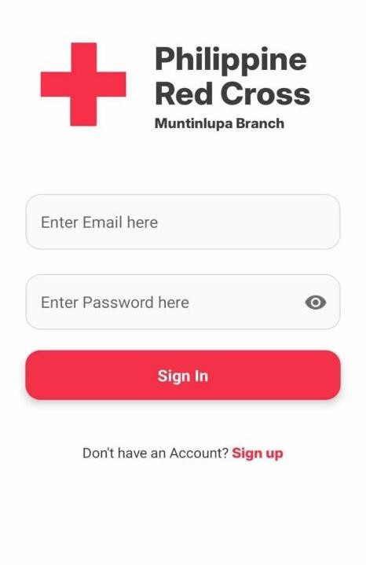
Figure9 Sign-In Page of Bloodlink Red Cross in Muntinlupa for Donors and Recipients
Figure 9 shows the sign-in form for the Admin, Donors, and Recipients. Users must enter their email address and password to access the system. If a user does not have an account, the system provides a sign-up form located below the sign-in button.
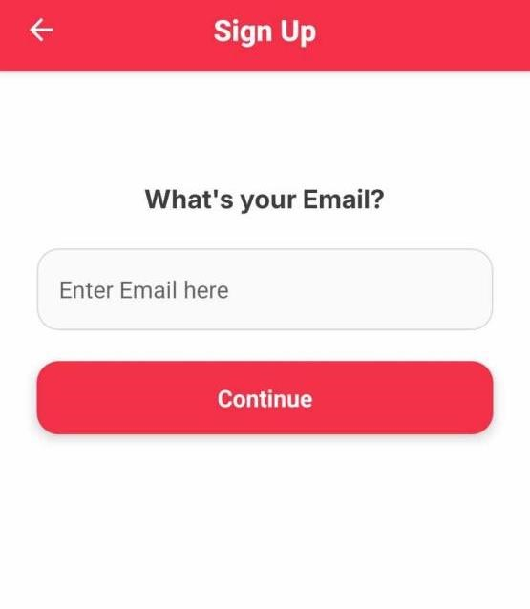
Figure10 Sign-Up Form
Figure 10 shows the sign-up form requiring an email address as the username and a profile photo to complete registration.
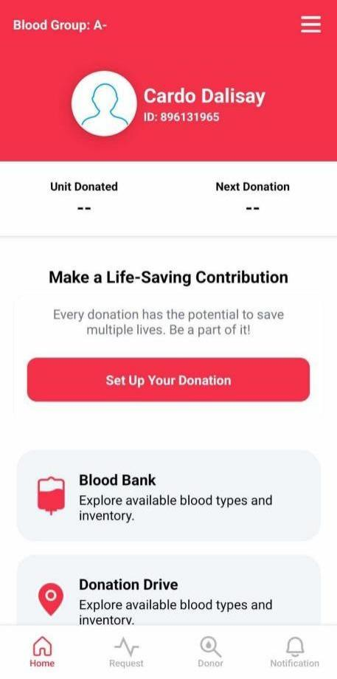
Figure11 Dashboard Page
Figure 11 shows the dashboard displaying the user's blood group, name, ID, and donation details. It includes options to set up donations, explore the Blood Bank, and view Donation Drives. The navigation bar provides quick access to Home, Requests, Donors, and Notifications.
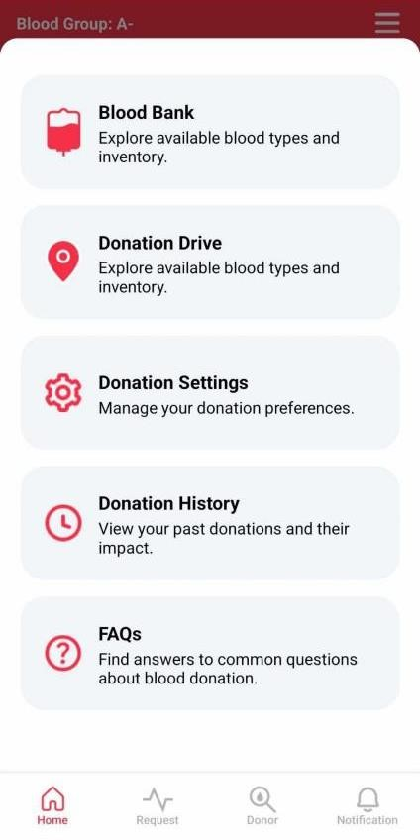
Figure12 Home Dashboard
Figure 12 shows the home dashboard, which provides quick access to features such as Blood Bank, Donation Drive, Donation Settings, Donation History, and FAQs. Users can easily navigate using the icons for Home, Requests, Donors, and Notifications at the bottom of the page.
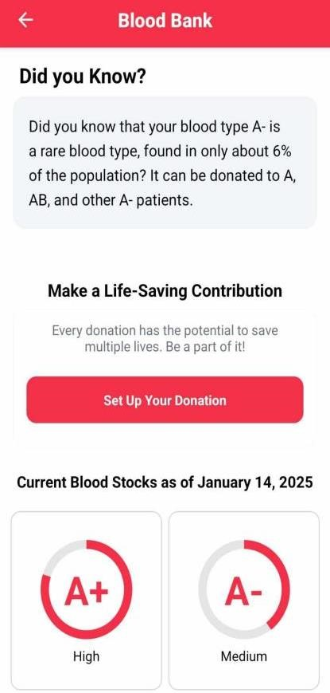
Figure13 Blood bank
Figure 13 encourages users to donate blood, featuring a “Set Up Your Donation” button. It highlights current blood stock levels, motivating users to contribute and make a life-saving impact
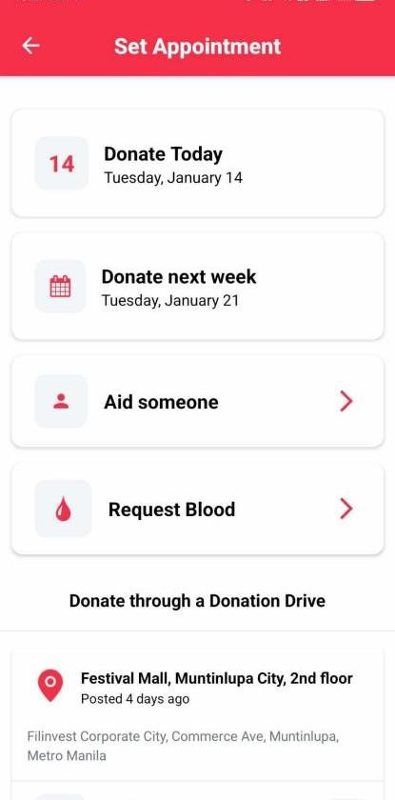
Figure14 Set Up Appointment Page
Figure 14 allow users to schedule their donations with options to donate today or next week .Users can also choose to aid someone or request blood. Additionally, it provides details for donating through a local donation drive at Festival Mall, Muntinlupa City.
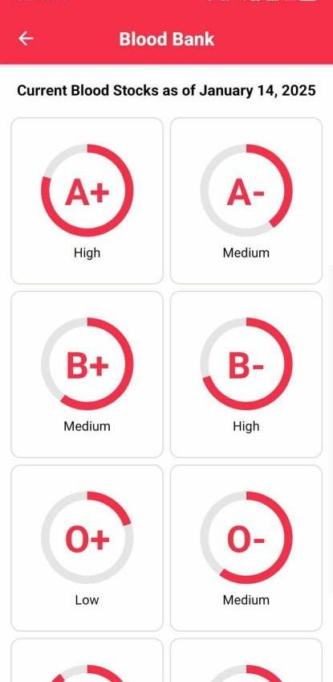
Figure15 Blood Stocks Page
Figure 15 presents the Blood Stocks Page, which displays the current inventory of blood types. Each blood type is shown alongside its stock status, categorized as High, Medium, or Low, providing users with real-time availability to support donation planning and urgent needs
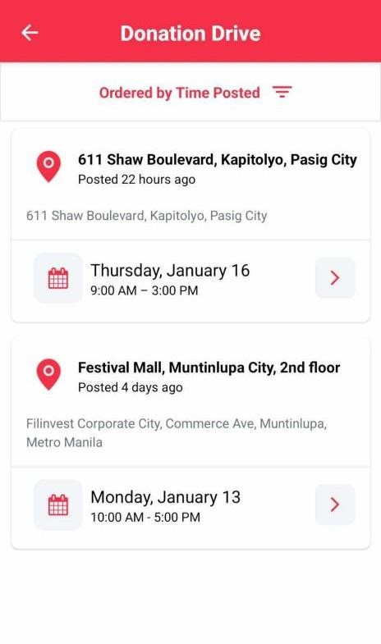
Figure16 Donation drive Page
Figure 16 shows the Donation Drive Page, where users can view details of upcoming and recent blood donation events, filter them by time posted, and pre-register for events. It simplifies participation in community blood drives.
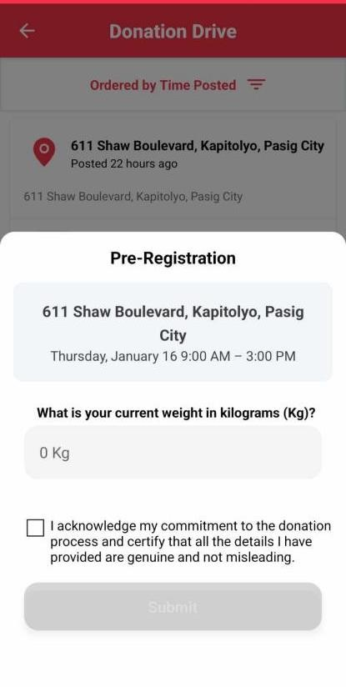
Figure17 Pre- Registration
Figure 17 allows users to pre-register for a donation drive, input their weight, and certify the information provided. It includes a commitment checkbox and a “Submit” button.
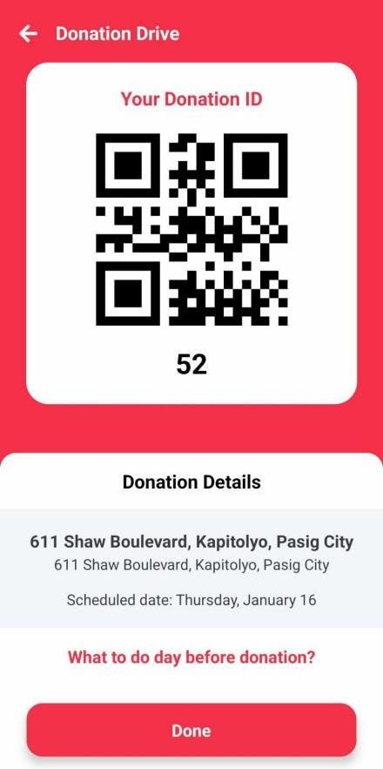
Figure18 Donation ID
Figure 18 shows the user’s Donation ID as a QR code, along with the donation location and date.Users can access pre-donation tips and confirm completion with the “Done” button.
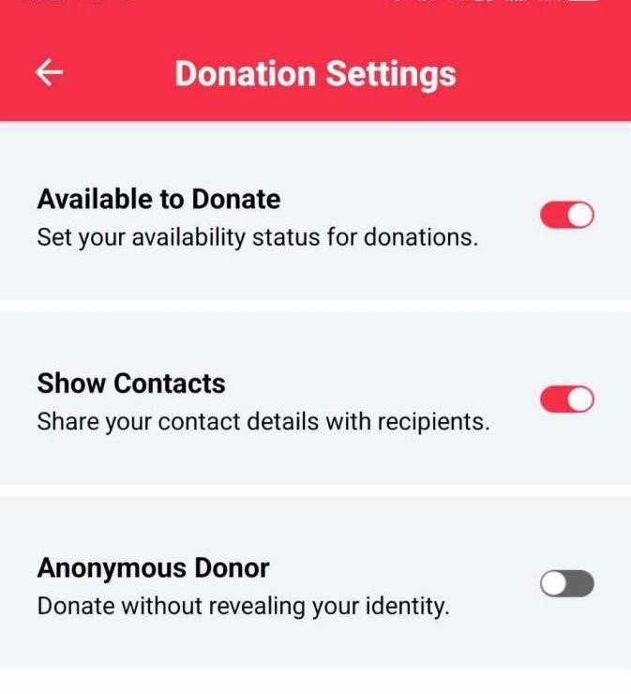
Figure19 Donation Settings
Figure 19 allows users to manage their donation preferences, including toggling availability for donations, sharing contact details, and opting for anonymous donations.
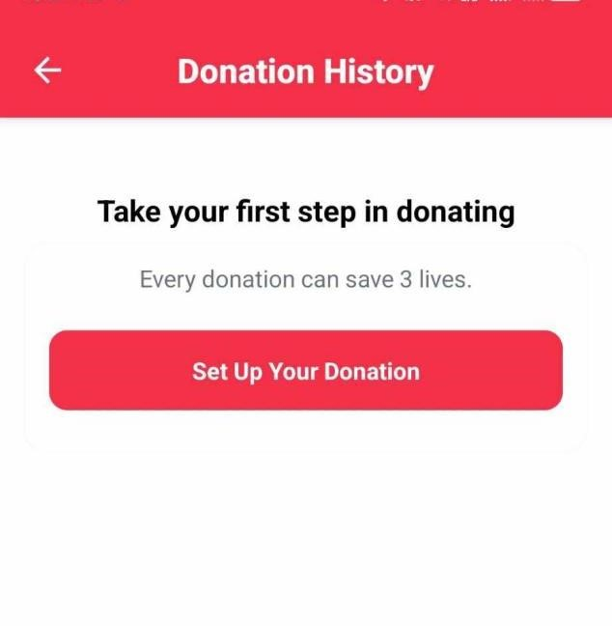
Figure20 Donation History Page
Figure 20 allows users to start their donation journey , emphasizing that each donation can save three lives. A “Set Up Your Donation” button encourages users to take action .
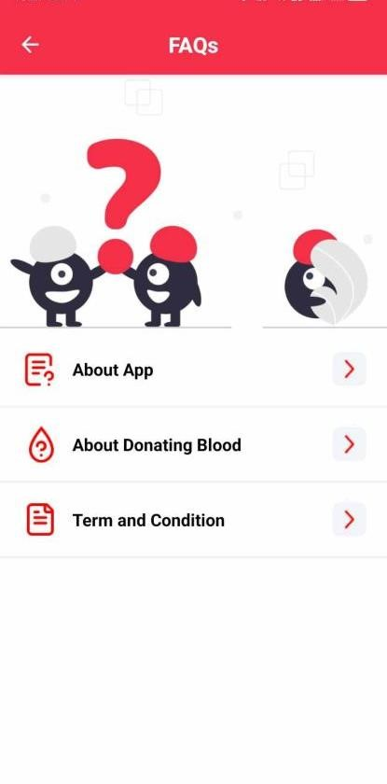
Figure21 FaQs Page
Figure 21 provides users with frequently asked questions covering three main sections : About the App, About Donating Blood , and Terms And Conditions.It offers essential information to help users understand the app’s features , the importance and process of blood donation, and the guidelines governing its use.
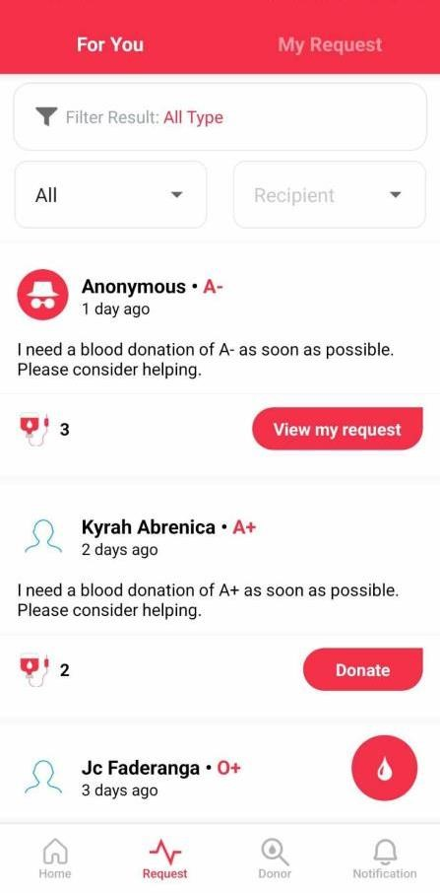
Figure22 Request Page
Figure 22 displays the Request Page, where users can filter and view blood donation requests. Requests are categorized under "For You" and "My Request." Each request provides details such as blood type, urgency, and donor count. Users can either donate or view their request status directly from this page for a seamless experience
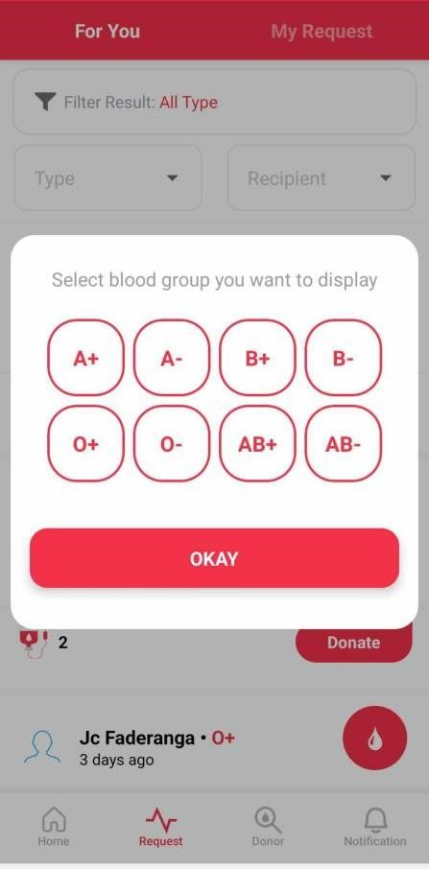
Figure23 Blood Group Selection Page
Figure 23 shows allows user to filter request by selecting a specific blood group.Options for all major blood types are displayed , and users can confirm their selection by tapping the “ Okay” button
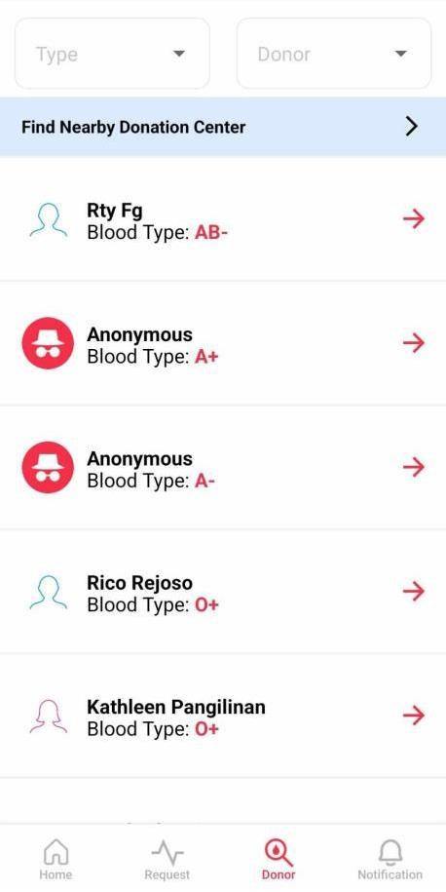
Figure24 Donor Page
Figure 24 showcases the Donor Page, where users can search and filter blood donors by blood type and availability. Donors are listed with their blood type, and each entry includes an option to view more details or contact the donor. Users can also find nearby donation centers and track their donation history for a streamlined and user friendly experience.
PROJECT CAPABILITIES AND LIMITATION
Capabilities
The following are the capabilities of the Mobile-Based Hybrid Blood Bank System:
- The system provides account creation and management for personalized user
access.
- The system provides health assessments for donors to determine eligibility
before scheduling.
- The system provides an intuitive interface for booking whole blood donation appointments.
- The system provides up-to-date information on available blood types and
quantities.
- The system provides reminders for upcoming appointments via the portal.
- The system provides assistance in finding nearby blood donation drives.
- The system provides information about the donation process, health tips, and FAQs to promote awareness.
- The system provides an option for donors and recipients to make their requests
or donations anonymous.
- The system offers donation settings for donors to choose whether to make their contact information public or hidden.
- The system provides filter functions for donors to filter by blood type, blood compatibility, and anonymous recipients.
- The system provides a history of whole blood donation.

- The system provides filters to sort donation centers by time posted or event date.
- The system provides in-app notifications.
- The system provides a module for admins where they can search for users, and manage donations and requests.
- The Admin Management system is capable of manually approving requests such as verification, donation ,and blood request.
- The system is capable to submit image and pdf files for supporting document with there request

Limitations
The following are the limitations of the Mobile-Based Hybrid Blood Bank System:
- System focuses only on the mobile application and excludes changes to
overall operations or staff processes of the Red Cross.
- System requires a stable internet connection for features like updates and appointment scheduling, which may not be feasible in areas with poor internet
access.
- The system is designed to support only Android devices running version 10 and above, excluding iOS users.
- The system is not capable of utilizing GPS for donation center addresses or
locations.

- The System only capable providing notifications via portal and not through email or push notification
- The system only handles whole blood donations and is not capable of handling
platelet and plasma donations.
- The system is not capable of tracking who the beneficiary of their donation drive
is.
- System can't provide compatible donor for unauthorized user but can filter blood type
- The System is not capable providing price for blood request
- The System does not support real time updates
- Some module on admin management is not set for mobile or not responsive
- The System is not capable to automatically check request such as verification,
donation and blood request.
PROJECT EVALUATION
To evaluate the project capabilities, the proposed system undergoes actual testing and evaluation process. Actual testing is done first by the researchers to ensure expected outcome is reached. The evaluation instrument provides a rating to scale the criteria for the software materials, where five (5) is the highest and 1 (1) is the lowest.

Table 6
Module | Testing Conducted | Result
User Registration | The system is capable of accepting username, password inputs, and checking email availability. | The system successfully accepts and validates inputs.
Login Authentication | The system verifies user credentials before granting access. | The system correctly authenticates valid users.
Profile Management | Users can update their profile information, such as name and contact details. | Profile information is updated and saved successfully.
Blood Donation Request | Users can submit a blood donation request with all required details. | Blood donation requests are stored in the database.
Blood Donation | Users can submit a blood donation to the selected recipient. | Blood donations are stored in the database.
Donation Drive | User can submit pre-registration for a selected donation drive | Pre-registration is stored in the database.
Filters Functionality | Users can filter blood type, compatibility, time posted and event dates. | Filter results are accurate and relevant.
Data Validation | The system validates all required fields during form submission. | The system flags empty or invalid fields correctly.

Testing Results
The table shows on how the proponents test the system in every function provided into the system. It is to ensure that the expected outcome is achieved
Table 7
Sample size of respondents
Respondents | Sample Size
Actual Users | 40
IT Expert | 10
Total | 50

The Testing results as shown in following tables were tested by fifty (50) evaluators, forty (40) actual users and ten (10) IT experts. The forty actual users consist of Muntinlupa blood donors and volunteers. The ten IT experts are in the field of the system and IT professionals working in an Information Technologies offices and companies, one (1) of them is IT professors of Pamantasan ng Lungsod ng Muntinlupa, one (1) is IT support and one (1) is Account Specialist and the remaining five (5) IT Alumni. The system’s final prototype was evaluated by the evaluators hence some changes and improvements are done with final output.

Table 8
Weighted Mean and Descriptive Rating of the Evaluation of the I.T. Experts using the
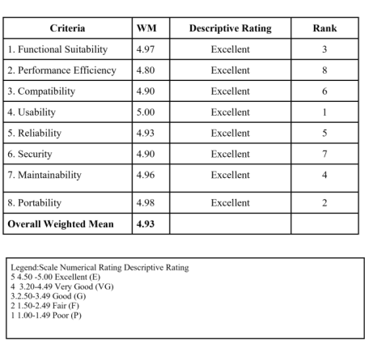
The summary of overall weighted mean score evaluation by the IT experts, as shown in the table, was 4.93, which is interpreted as “Excellent.” The following characteristics of the evaluation were on Functional Sustainability, which scored 4.93 and was interpreted as “Excellent,” and another one on the area of Performance efficiency which was 4.80 and interpreted as “Excellent”, the Compatibility characteristics was rated 4.90 which is equivalent to “Excellent”, the Usability was rated 5.00 and rated as “Excellent”. The Reliability was scored 4.93 which is equivalent to “Excellent”, Security was rated 4.90 and interpreted as “Excellent”, the Maintainability was scored 4.96 which is interpreted as “Excellent”, and lastly the Portability characteristics was rated 4.98 which is equivalent to “Excellent”.

Table 9
Weighted Mean and Descriptive Rating of the Evaluation of the Actual Users using
the ISO/IEC 25010:2011 Software Evaluation
 | Criteria | WM | Descriptive Rating | Rank
 | 1.Functionality | 4.83 | Excellent | 4
 | 2Reliability | 4.87 | Excellent | 3
 | 3. Usability | 4.95 | Excellent | 1
 | 4. Efficiency | 4.83 | Excellent | 5
 | 5. Portability | 4.90 | Excellent | 2
 | Overall Weighted Mean | 4.88 | Excellent
Legend:Scale Numerical Rating Descriptive Rating
5 4.50 -5.00 Excellent (E)
4 3.20-4.49 Very Good (VG)
3.2.50-3.49 Good (G)
2 1.50-2.49 Fair (F)
1 1.00-1.49 Poor (P)

The summary of overall weighted mean score evaluation by the users as shown in table was 4.88 which is interpreted as “Excellent”. The following characteristics of evaluation were on Functionality which was scored 4.83 and was interpreted as “Excellent”, another one on the area of Reliability which was 4.87 and interpreted as
“Excellent”, the Usability was rated 4.95 and rated as “Excellent”. The Efficiency was scored 4.83 which is equivalent to “Excellent”, and lastly the Portability characteristics was rated 4.90 which is equivalent to “Excellent”.

CHAPTER 5
SUMMARY OF FINDINGS, CONCLUSIONS AND RECOMMENDATION
The Project Development of Bloodlink: Mobile-Based Hybrid Blood Bank for Red Cross Muntinlupa Chapter went to actual testing and evaluation from 50 evaluators including 40 actual users and 10 IT experts. It is found that the developed system is effective and useful. They also agreed that the system’s user interface is user friendly and understandable by actual users.
Based on the Evaluation of IT Experts
For I.T Experts
- Functionality suitability: The respondents rated the project "Excellent" because it ensures the completeness and appropriateness of its functions.
- Performance efficiency: The respondents rated the project "Excellent" because it is easy to use and operates efficiently.
- Usability: The respondents rated the project "Excellent" because it is user-friendly and promotes efficiency.
- Reliability: The respondents rated the project "Excellent" because it is consistently available and accessible when required;
- Maintainability: The respondents rated the project "Excellent" because of its effectiveness and efficiency in system maintenance.
- Portability: The respondents rated the project "Excellent" because it was successfully installed and functions properly on mobile devices.
Based on the Evaluation of Actual Users

For Actual Users
- Functionality: The respondents rated the project "Excellent" because it ensures the proper execution of features, meeting user needs effectively.
- Usability: The respondents rated the project "Excellent" because it is easy to use and has a user-friendly interface.
- Reliability: The respondents rated the project "Excellent" because of its accuracy in performance, ensuring dependable system functionality. .
- Availability: The respondents rated the project "Excellent" because of its completeness and consistent performance, making the system reliable and accessible when needed.

CONCLUSION
The following conclusions were derived based on the concerns stated in the
objectives of the study and result of the evaluation conducted.
- That the system is designed and developed for the Red Cross Muntinlupa Chapter to modernize blood banking operations.
- That the system is able to cater to two (2) different user types: donors and recipients.
- That the system is capable of facilitating essential functionalities such as registration, appointment scheduling, and real-time blood inventory monitoring.
- That the system provides timely notifications for blood donation campaigns and urgent blood supply needs.
- That the system enhances accessibility and efficiency in blood donation management by integrating mobile technology with traditional blood bank operations.
- That the developed system was constructed as designed and tested successfully for functionality, usability, and compatibility with the existing infrastructure.
- That the system was evaluated by IT experts and actual users, achieving positive feedback for its performance, accessibility, and reliability.

- That the system was evaluated by the IT experts and Actual Users with an overall mean score of 4.90 and was rated “ Excellence” based from the evaluation prepared and adopted from ISO/IEC 25010:2011 and

- That the system has been implemented and deployed successfully, benefiting the Muntinlupa community and strengthening its healthcare infrastructure.

RECOMMENDATION
- The system should enforce robust security measures, such as encrypted data storage and secure authentication protocols, to protect user data and maintain trust
- The system should allow users to create personalized profiles.
- To enhance user engagement, Add gamification features, such as badges or rewards, to encourage regular donations.
- Include a real-time matching system for donors and recipients based on blood type, location, and urgency for quicker emergency responses.
- The system should have an offline mode, so users can still access essential features even when they have limited or no internet connection.
- To improve coordination, the system should be linked with hospitals, clinics, and healthcare providers, making it easier for them to request and manage blood supply.
- The system should provide visual and audio guidance, such as instructional videos or step-by-step guides, to assist first-time donors in understanding the process.

- Automated reminders and notifications via SMS or push alerts should be added to help donors stay on schedule and reduce missed appointments.
- A simple mode or accessibility settings should be available for elderly users or those who are not tech-savvy, making the interface easier to navigate.
- The system should include ID validation, email validation, and a captcha on the login page for enhanced security.

PICTURES SHOWCASING THE DATA GATHERING, INVESTIGATION DONE
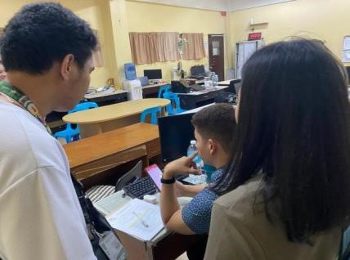

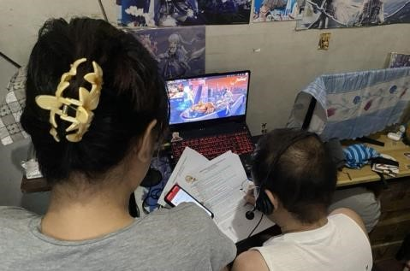

GANTT CHART
TASK NAME
 | May | Jun | Jul | Aug | Sep | Oct | Nov | Dec | Jan | Feb | Mar
Submission 3 Proposed Topics
Topic Defense with Panel of Experts
Data gathering and Requirements
Writing the 1st Chapter
Writing the 2nd Chapter
Writing the 3rd Chapter
Checking and Revising of Chapter 1,2,3
System Development
Pilot Testing and Evaluation
Writing the 4th Chapter
Writing the 5th Chapter
Final Defense
Revision of Research Document
Finalization and Binding Manuscript

CURRICULUM VITAE

Name | : | Janrey Cyril C. Faderanga
Contact No. | : | 09911445131
Email Address | : | jcfaderanga@gmail.com
Address | : | BLK 13 LOT 13 Malugay ST. Pupa Homes 1 Summitville Putatan Muntinlupa City
Date of Birth | : | January 21, 2003
Place of Birth | : | Muntinlupa City
Civil Status | : | Single
Religion | : | Roman Catholic
EDUCATIONAL BACKGROUND | :
Tertiary | : | Pamantasan ng Lungsod ng Muntinlupa  University Road, NBP Reservation Poblacion Muntinlupa City  Bachelor of Science in Information Technology  S.Y 2021 – 2025
Senior High School | : | Muntinlupa National High School Main  S.Y 2019 – 2021
Junior High School | : | Lakeview Integrated School
Primary | : | Muntinlupa Elementary School


Name | : | Kyrah A. Pangilinan
Contact No. | : | 09911216157
Email Address | : | kyrahpangilinan118@gmail.com
Address | : | 515 Cattleya Putatan Muntinlupa City
Date of Birth | : | July 27,2002
Place of Birth | : | Sta.Maria Bauan Batangas
Civil Status | : | Single
Religion | : | Roman Catholic
EDUCATIONAL BACKGROUND | :
Tertiary | : | Pamantasan ng Lungsod ng Muntinlupa  University Road, NBP Reservation Poblacion Muntinlupa City  Bachelor of Science in Information Technology  S.Y 2021 – 2025
Senior High School | : | Zacarias C Aquilizan High School  Panabingan San Antonio Nueva Ecija  S.Y 2019 – 2021 With Honor
Junior High School | : | Zacarias C Aquilizan High School  Panabingan San Antonio Nueva Ecija
Primary | : | Panabingan Elementary School


Name | : | Mary Grace S. Santarin
Contact No. | : | 09999078865
Email Address | : | santarinmarygrace_act@plmun.edu.ph
Address | : | Makabuhay Upper Street Poblacion, Muntinlupa City
Date of Birth | : | September 30, 2002
Place of Birth | : | Muntinlupa City
Civil Status | : | Single
Religion | : | Roman Catholic
EDUCATIONAL BACKGROUND | :
Tertiary | : | Pamantasan ng Lungsod ng Muntinlupa  University Road, NBP Reservation Poblacion Muntinlupa City  Bachelor of Science in Information Technology  S.Y 2021 – 2025
Senior High School | : | Muntinlupa National High School Main  S.Y 2019 - 2021
Junior High School | : | Muntinlupa National High School Main  S.Y 2015 - 2019
Primary | : | Itaas Elementary School

REFERENCES
- Li L, Valero M, Keyser R, Ukuku AM, Zheng D. Mobile applications for encouraging blood donation: A systematic review and case study. Digit Health. 2023 Oct 8;9:20552076231203603. doi: 10.1177/20552076231203603. PMID: 37822963; PMCID: PMC10563464.

- O. Iparraguirre-Villanueva, F. Sierra-Liñan, M. Cabanillas-Carbonell, “ 2022 Location-based Mobile Application for Blood Donor Search”.
https://repositorio.uwiener.edu.pe/handle/20.500.13053/6889

- Gupta, S. Singh, P. Kumar, “ 2019 Blood Bank Android Application Collection Centre,” http://www.ir.juit.ac.in:8080/jspui/handle/123456789/6750

- Moh. Nabil et al 2020 J. Phys.: Conf. Ser. 1447
012001,https://iopscience.iop.org/article/10.1088/1742-6596/1447/1/012001/meta

- Al-Sammarraie, et.al (2022) Mobile-base Registration System for Blood Donation (MBRS-BD). Asian Journal of Research in Computer Science, 14 (4). Pp. 36-45. ISSN
2581-8260 http://scholar.sdpublishers.info/id/eprint/22/

- Ocen, et.al 2022 http://196.43.171.194/handle/20.500.12283/2467

- Lawas, K. , Glorioso, J. & Capuno, J. (2023). Sagot Ko Dugo Mo: A Blood Management System with Donor Finder for Red Cross Laguna Chapter. Ani: Letran Calamba
Research Report, 19(1), 54-55.https://www.ejournals.ph/article.php?id=1965820

[8]. M. M. Hummady, "Design Mobile Application for Blood Donation System,"2022 International Conference on Computer and Applications (ICCA), Cairo, Egypt, 2022, pp. 1-5,doi: 10.1109/ICCA56443.2022.10039544

- A Research Paper on “ Blood Donation Management System" by A. Clemen Teena, K. Sankar (2021)

- Brasil Pan-Americana da Saúde (OPAS). Dia Mundial do Doador de Sangue 2019
Sangue seguro para todos (2019)

- G. Maji, N. C. Debnath and S. Sen, "Data Warehouse Based Analysis with Integrated Blood Donation Management System," 2018 IEEE 16th International Conference on Industrial Informatics (INDIN), Porto, Portugal, 2018, pp. 855-860, doi: 10.1109/INDIN.2018.8471988.
- A. Casabuena et al., "BloodBank PH: A Framework for an Android-based Application for the Facilitation of Blood Services in the Philippines," TENCON 2018 - 2018 IEEE Region 10 Conference, Jeju, Korea (South), 2018, pp. 1637-1641, doi:
10.1109/TENCON.2018.8650395

- Tatikonda VK, El-Ocla H. BLOODR: blood donor and requester mobile application. Mhealth. 2017 Sep 18;3:40. doi: 10.21037/mhealth.2017.08.08. PMID: 29184892; PMCID: PMC5682362.

- Kulkarni, S. S., & Kulkarni, S. S. (2016). Mobile Blood Donation System for Blood
Banks. International Journal of Computer Applications, 134. https://doi.org/10.5120/ijca2016909732

- M. R. A. Brislin, J. A. Mayan, R. A. Canessane and M. R. A. Hamlin, "Blood donation and life saver app," 2017 2nd International Conference on Communication and Electronics Systems (ICCES), Coimbatore, India, 2017, pp. 446-451, doi:
10.1109/CESYS.2017.8321318.

- M. Fahim, H. I. Cebe, J. Rasheed and F. Kiani, "mHealth: Blood donation application using android smartphone," 2016 Sixth International Conference on Digital Information and Communication Technology and its Applications (DICTAP), Konya, Turkey, 2016, pp. 35-38, doi:10.1109/DICTAP.2016.7543997.

- American Red Cross. (2025). "Understanding the Blood Donation Process." Retrieved from https://www.redcross.org . A comprehensive explanation of the steps involve in donating blood and its significance in saving lives.

- Facebook,"Post by Philippine Red Cross,"Facebook.Available: https://www.facebook.com/share/p/15hUkkfqPkn.

- YouTube, "BLOOD DONATION PROCESS,DOS DON'TS,MYTHS,BENEFITS| PHILIPPINE RED CROSS|EDUCATIONAL MOTORCYCLE VLOG," YouTube Available: https://www.youtube.com/watch?v=4H4cGW9vaW0.

- YouTube, "UH Clinic— Blood Donation | Unang Hirit," YouTube. Available: https://www.youtube.com/watch?v=DOc5D7pWV1I.

- Google Docs, "How is my Blood Type Determined?," Google Docs. Available: https://docs.google.com/document/d/1-tlf_a8z0uhjq3vVXluYHeSt6rHrqKGJkuWwt91HbU/edit.

- Facebook, "Post by Dr. Anne Kristine H. Quero ," Facebook. Available: https://www.facebook.com/share/p/12Cunar4hwa/.

- OpenAI,"units to donate," ChatGPT. Available: https://chatgpt.com/share/67753a34bf3c-8003-b318-be1a08c8dc4a.

- American Red Cross, "Official Website," Red Cross, [Online]. Available: https://www.redcross.org/.

- IJRSET, "Blood Bank App Management Using Android Application," International Journal for Research in Applied Science and Engineering Technology (IJRASET), [Online]. Available:https://www.ijraset.com/research-paper/blood-bank-app-management-usingandroid-application

- YouTube, "Red Cross blood donor app connects donors to their 'blood journey'," YouTube, [Online]. Available: https://youtu.be/gIc9xWod6h4.

